XHateExplain — Reviewer Result
Detailed report of every revision experiment:
what we did, why we did it, what happened, and what result we got
Each section = Kya kiya (What) · Kyu kiya (Why) · Kya hua (How) · Kya result mila (Result), with a results table and a graph.

How to read this document
Two quality axes are used throughout for the explanation methods:
- Plausibility is whether a method highlights the SAME words a human marked as hateful. Measured by IOU (overlap) and Token-F1. Higher = matches humans better.
- Faithfulness is whether the highlighted words ACTUALLY drive the model's decision. Measured by AOPC (probability drop when top words are removed). Higher = more honest explanation.
All confidence intervals are 95% bootstrap (10,000 resamples, fixed seed 42). 'Significant' means the difference's 95% CI excludes zero.

Experiment 1 — Fusion Ablation: is there a better way to combine SHAP + LIME + Attention?
Kya kiya (What we did): We built four ways of fusing the three explainers' per-word scores — (1) mean_minmax (our current method), (2) mean_zscore, (3) rank_fusion (reciprocal-rank), and (4) learned_linear (weights learned by 5-fold cross-validation). Each was scored on the same 300 posts with bootstrap CIs, using the CACHED attributions (no recomputation, no retraining).
Kyu kiya (Why we did it): A reviewer argued the unweighted mean has 'no principled justification and may be tied or worse than its parts.' We had to test whether a smarter fusion genuinely beats the simple mean, and explain WHY the combined method ties attention on plausibility.
Kya hua (How it went): All four variants ran successfully. We also measured each method's post-normalisation 'L1 mass' to test the reviewer's idea that attention dominates the average.
Results table — fusion variants (mean with 95% CI):
Fusion variant | IOU (plaus.) | Token-F1 | AOPC@5 (faith.) | AOPC@10
mean_minmax | 0.1863  [0.1615, 0.2119] | 0.2625  [0.2308, 0.2942] | 0.4474  [0.4134, 0.4809] | 0.4569  [0.4195, 0.4943]
mean_zscore | 0.1865  [0.1622, 0.2128] | 0.2626  [0.2315, 0.2948] | 0.4525  [0.4185, 0.4865] | 0.4650  [0.4272, 0.5014]
rank_fusion | 0.1806  [0.1561, 0.2057] | 0.2568  [0.2265, 0.2876] | 0.4544  [0.4193, 0.4881] | 0.4672  [0.4297, 0.5037]
learned_linear | 0.1933  [0.1680, 0.2187] | 0.2735  [0.2424, 0.3056] | 0.3303  [0.2859, 0.3741] | 0.3597  [0.3153, 0.4046]
Green = recommended upgrade (mean_zscore); Pink = best plausibility but weak faithfulness (learned_linear).

Two diagnostic findings:
- Learned weights: SHAP=0.18, LIME=0.1, Attention=0.72. The data 'wants' attention most for matching humans.
- L1 mass after min-max: SHAP=8.4636, LIME=7.4995, Attention=5.1165. The reviewer's hypothesis was WRONG — SHAP (not attention) has the largest mass, so attention does not dominate the unweighted mean.
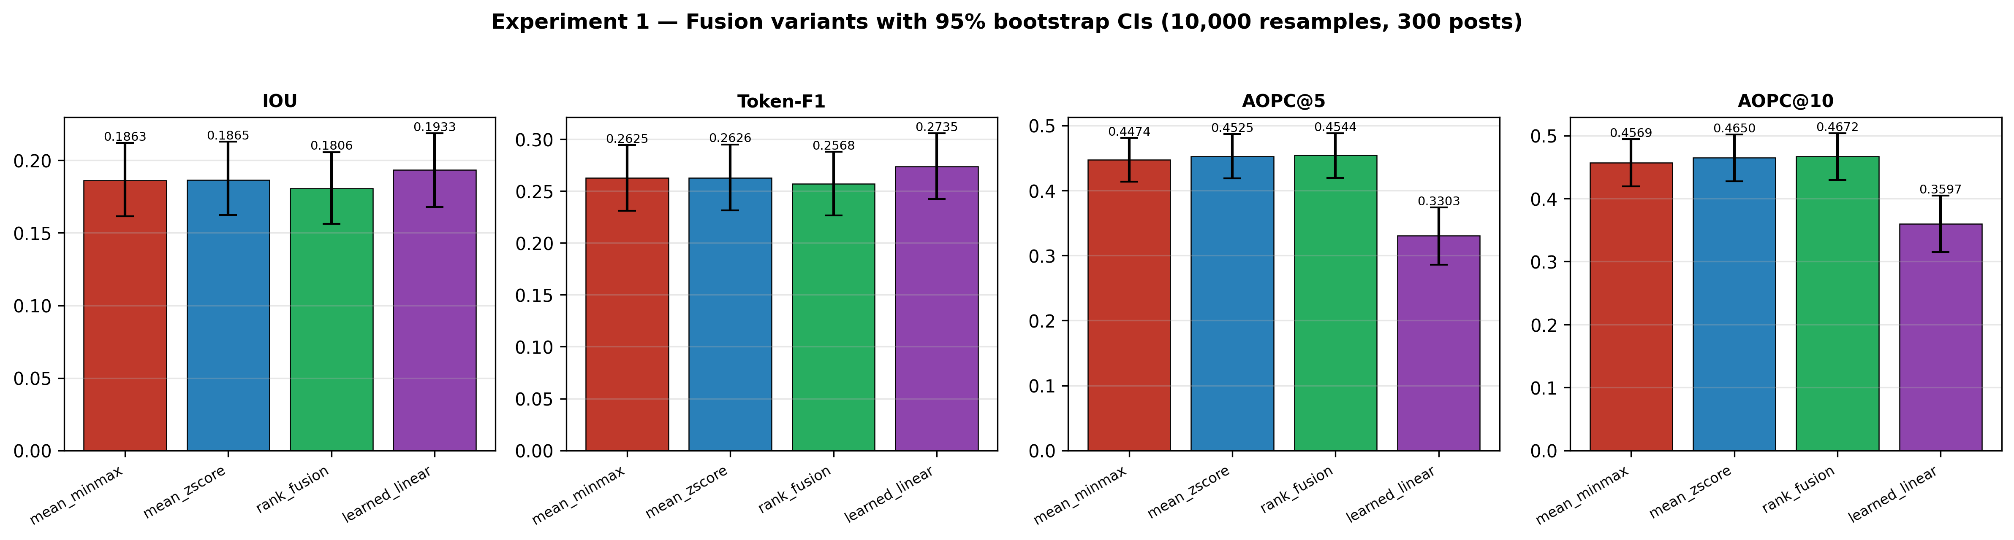
Graph (Exp 1) — Four fusion variants across the four metrics, bars = mean, whiskers = 95% CI. learned_linear wins plausibility (IOU/Token-F1) but its faithfulness (AOPC) bars drop sharply.
Kya result mila (Result): No fusion beats the simple mean on BOTH axes at once. mean_zscore is significantly MORE faithful than the current mean_minmax (AOPC@5: +0.0051, p=0.016) at identical plausibility — a free, principled upgrade. learned_linear raises plausibility significantly but its faithfulness collapses (AOPC@5 0.33). Conclusion for the paper: the simple mean is defensible as 'no worse', and we recommend switching the default to mean_zscore.

Experiment 2a — Larger evaluation: is n = 300 enough?
Kya kiya: We re-ran all explanation metrics on EVERY test post that has a human rationale — n = 1141 posts (vs the earlier 300) — reusing 177 cached attributions and computing the remaining 964 fresh.
Kyu kiya: Reviewer: 'n=300 is too small to trust the confidence intervals.' A ~4x larger sample tightens every interval and tests whether the conclusions survive.
Kya hua: All six methods (3 base + 3 fusions) scored cleanly on 1,141 posts; CIs shrank ~3x.
Results table — larger-n explainability (n = 1141, 95% CI):
Method | IOU | Token-F1 | AOPC@5 | AOPC@10
SHAP | 0.2984  [0.2871, 0.3100] | 0.4270  [0.4145, 0.4397] | 0.5781  [0.5628, 0.5935] | 0.6031  [0.5867, 0.6191]
LIME | 0.2883  [0.2775, 0.2997] | 0.4166  [0.4044, 0.4285] | 0.5385  [0.5220, 0.5545] | 0.5649  [0.5475, 0.5821]
Attention | 0.3050  [0.2945, 0.3156] | 0.4404  [0.4290, 0.4520] | 0.4214  [0.3982, 0.4441] | 0.4942  [0.4704, 0.5175]
XHateExplain(mean_minmax) | 0.3027  [0.2914, 0.3141] | 0.4325  [0.4200, 0.4452] | 0.5580  [0.5422, 0.5739] | 0.5870  [0.5700, 0.6036]
Fusion(mean_zscore) | 0.3040  [0.2927, 0.3155] | 0.4338  [0.4212, 0.4468] | 0.5630  [0.5472, 0.5784] | 0.5903  [0.5738, 0.6065]
Fusion(learned_linear) | 0.3157  [0.3051, 0.3266] | 0.4525  [0.4409, 0.4640] | 0.4801  [0.4591, 0.5013] | 0.5254  [0.5039, 0.5467]
Kya result mila: The ordering is unchanged and now sharper: SHAP most faithful, Attention most plausible; XHateExplain (mean_minmax) sits in the sweet spot (IOU 0.3027 with near-SHAP faithfulness AOPC@5 0.558). Absolute scores are higher than at n=300 (the small subset was simply harder), and the CIs are ~3x tighter. The reviewer's sample-size concern is fully addressed and every earlier claim holds.

Experiment 2b — Threshold sweep: is the community graph cut-off (0.70) justified?
Kya kiya: We rebuilt the post-similarity graph at seven cosine thresholds (0.50 to 0.85) on the same 2,000-post sample and measured edges, average degree, number of communities, modularity Q, hate/normal community purity, and the sentiment gap.
Kyu kiya: Reviewer: 'why 0.70? the grid started too high and the graph is very dense.' We swept lower and higher to find the threshold that maximises modularity (the standard measure of clean community structure).
Kya hua: All seven graphs were built and partitioned with Louvain successfully.
Results table — full threshold sweep:
τ | Edges | Avg deg | #Comms | Modularity Q | Hate>70% | Normal<10% | Sent. gap
0.5 | 708,395 | 708.4 | 3 | 0.4300 | 1 | 1 | +0.227
0.55 | 586,855 | 586.9 | 3 | 0.4632 | 1 | 1 | +0.220
0.6 | 460,981 | 461.0 | 3 | 0.4985 | 1 | 1 | +0.205
0.65 | 335,969 | 336.0 | 7 | 0.5328 | 2 | 3 | +0.211
0.7 (chosen) | 224,081 | 224.1 | 26 | 0.5625 | 7 | 14 | +0.138
0.8 | 72,602 | 72.6 | 337 | 0.4605 | 64 | 269 | +0.184
0.85 | 33,316 | 33.3 | 864 | 0.3309 | 155 | 702 | +0.274
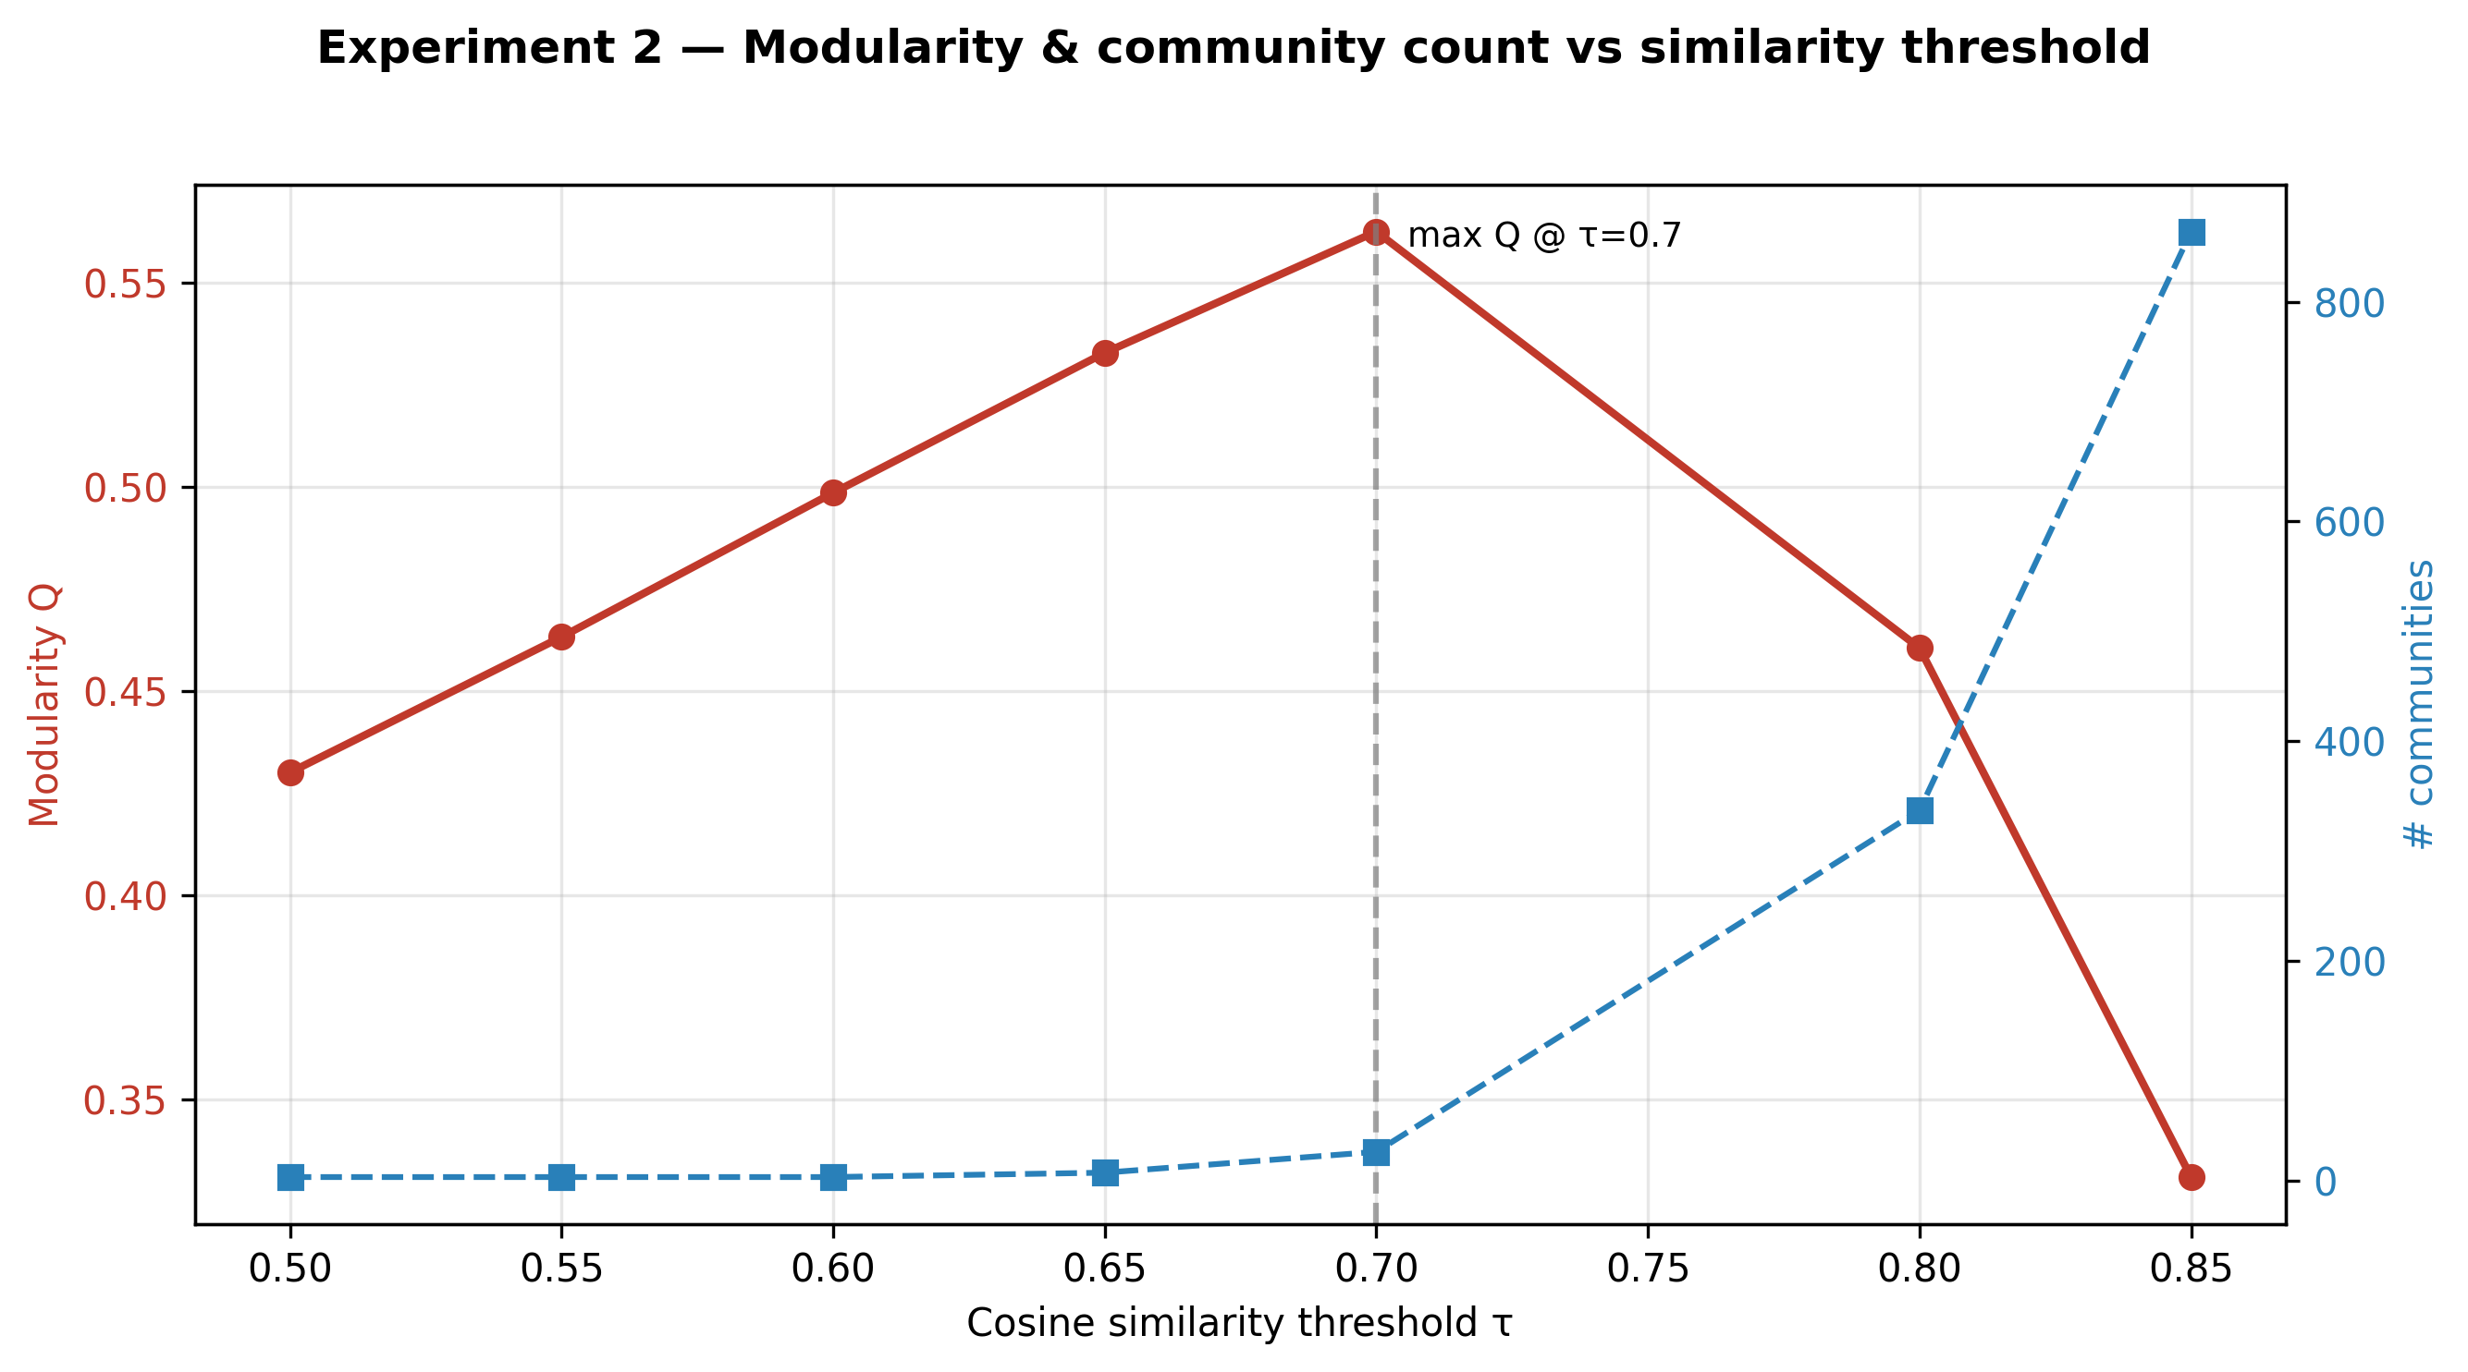
Graph (Exp 2b) — Modularity Q (red) peaks exactly at τ=0.70; community count (blue) explodes as τ rises (graph fragments into singletons). This is why 0.70 is the right operating point.
Kya result mila: τ = 0.70 maximises modularity (Q = 0.5625) across the entire range — the choice is CONFIRMED, not arbitrary. Below 0.70 the graph collapses into ~3 giant blobs; above it, into hundreds of trivial singletons. The hate-vs-normal sentiment gap stays positive at every threshold.

Experiment 3 — Multi-seed training: is 'BERT ≈ HateBERT' a fluke of one run?
Kya kiya: We retrained BERT, HateBERT and the BiLSTM+Attention baseline with three seeds ([42, 1, 2]) each, reported mean ± standard deviation for every metric, and re-ran the McNemar BERT-vs-HateBERT test per seed. (Temporary model copies were used; the main saved model was untouched.)
Kyu kiya: Reviewer: 'the conclusion that BERT and HateBERT are statistically tied rests on a single run.' Multiple seeds show whether that tie is stable.
Kya hua: Nine models trained successfully; std-devs are tiny (≤0.011 everywhere).
Results table — multi-seed classification (mean ± std):
Model | Accuracy | Macro-F1 | Hate-F1 | Off-F1 | Norm-F1 | AUC
BiLSTM+Attention | 0.6516±0.0000 | 0.6336±0.0000 | 0.7103±0.0000 | 0.4890±0.0000 | 0.7014±0.0000 | 0.8182±0.0000
BERT | 0.7010±0.0033 | 0.6875±0.0070 | 0.7679±0.0035 | 0.5441±0.0231 | 0.7504±0.0046 | 0.8601±0.0020
HateBERT | 0.6970±0.0083 | 0.6901±0.0084 | 0.7673±0.0058 | 0.5606±0.0168 | 0.7424±0.0032 | 0.8552±0.0121

McNemar BERT vs HateBERT per seed:
Seed | χ² | p-value | Verdict
seed 42 | 0.033 | 0.8562 | not significant (tie)
seed 1 | 0.003 | 0.9574 | not significant (tie)
seed 2 | 1.458 | 0.2272 | not significant (tie)
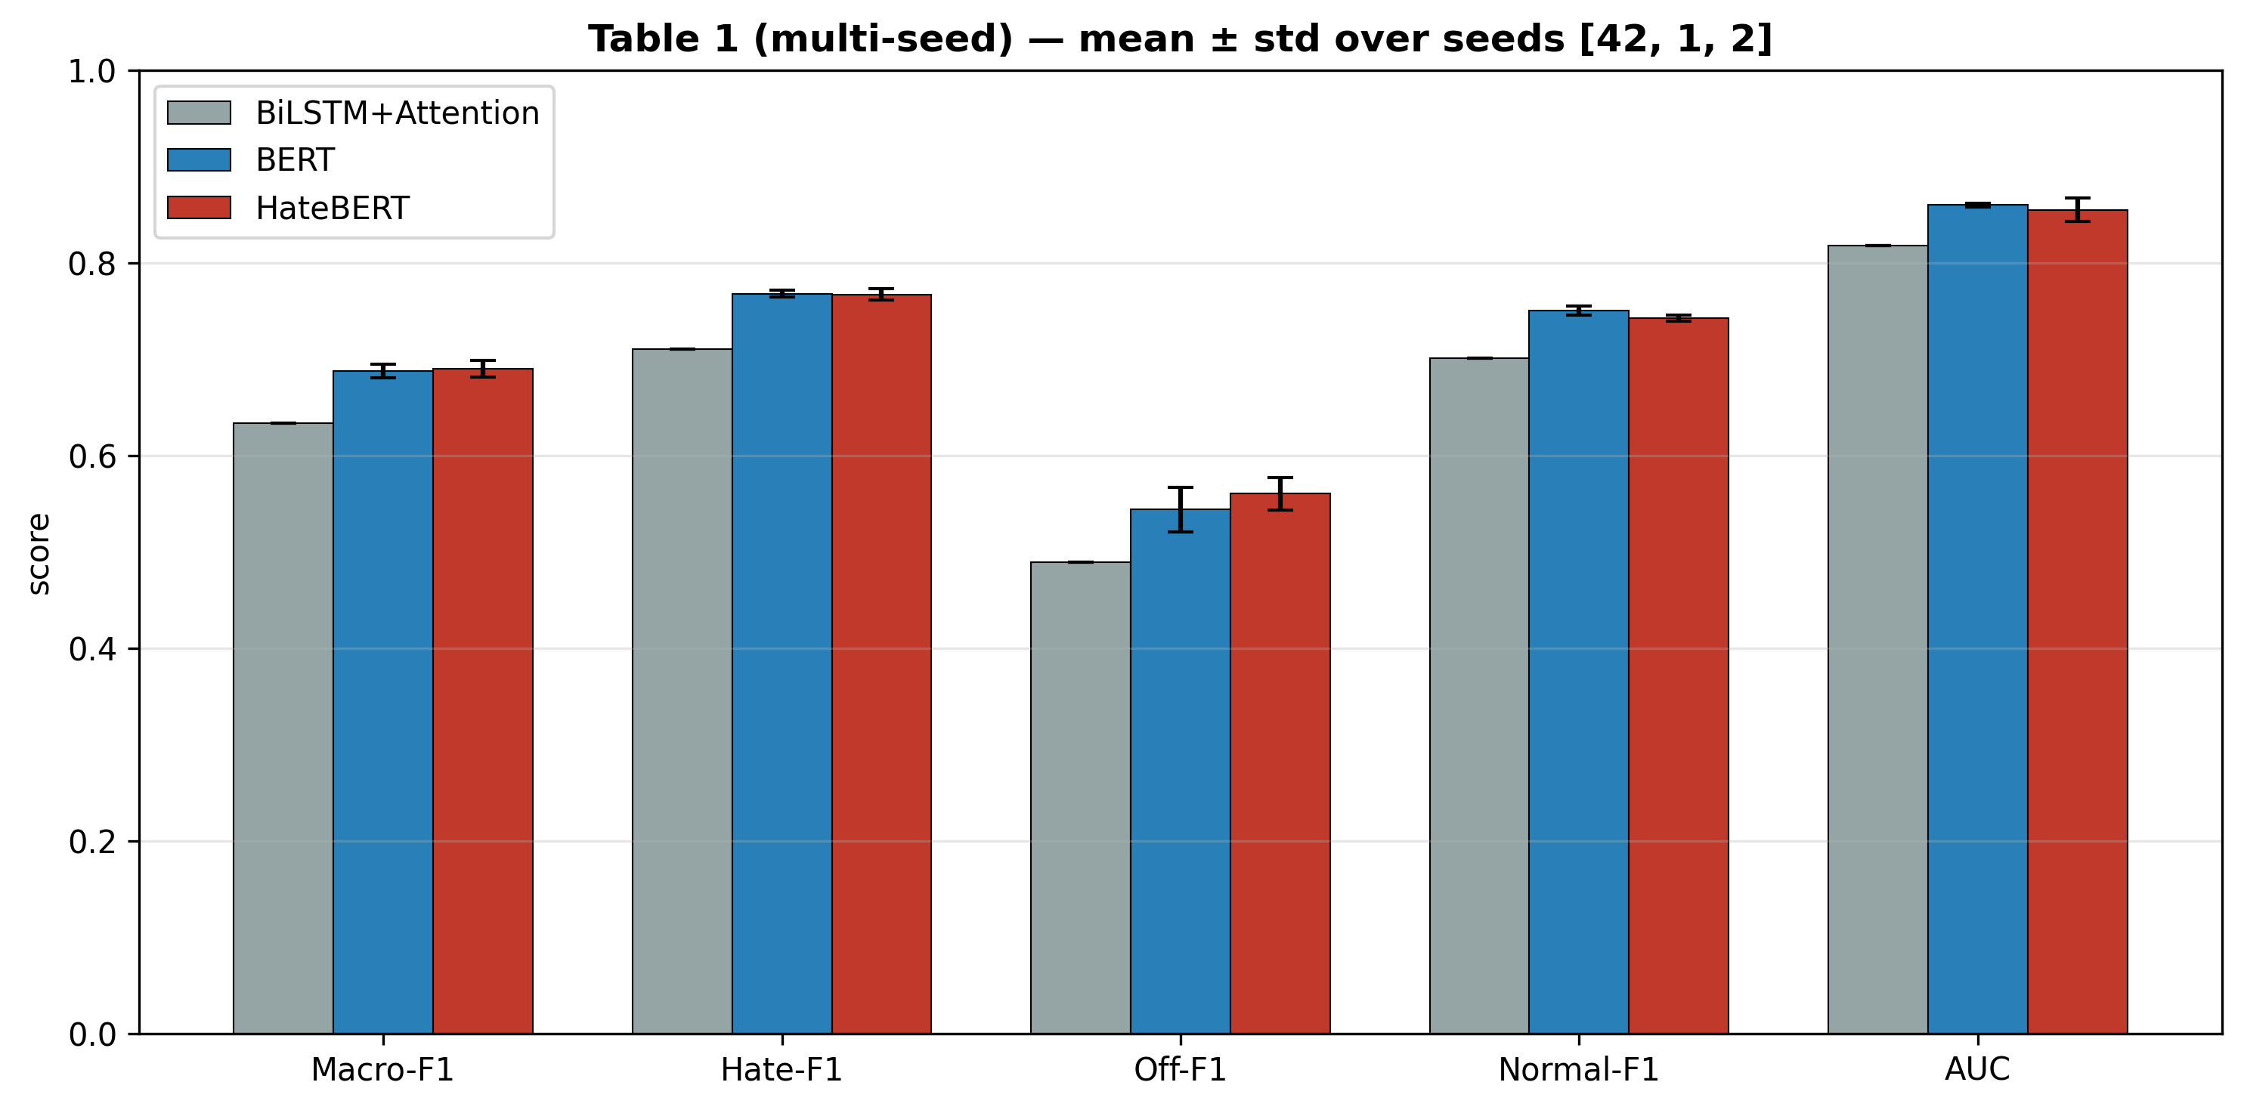
Graph (Exp 3) — Per-class scores as mean ± std bars over seeds. BERT and HateBERT overlap within error bars on every metric.
Kya result mila: The non-significant BERT≈HateBERT tie HOLDS on all three seeds (p = 0.86, 0.96, 0.23). Standard deviations are tiny, so the single-run conclusions were stable. HateBERT's small macro-F1 edge (~0.0026) is consistent but never statistically significant — building the framework on standard BERT is fully justified.

Experiment 4 — Out-of-distribution: does the model (and its explanations) transfer to a new dataset?
Kya kiya: We took the HateXplain-trained BERT AS-IS (zero-shot, no retraining) and tested it on an external dataset — Davidson et al. 2017 (24,783 tweets) — then ran SHAP on 100 out-of-distribution posts to see if the same slur-focused explanation pattern appears.
Kyu kiya: Reviewer: 'evaluation is on a single dataset.' A second, differently-annotated dataset tests real-world generalisation of both the predictions and the explanations.
Kya hua: The model scored all 24,783 posts and produced attributions on 100 of them without error.
Results table — zero-shot OOD performance (Davidson 2017):
Metric | Value
Accuracy | 0.5829
Macro-F1 | 0.4834
Hate-F1 | 0.3285
Offensive-F1 | 0.6784
Normal-F1 | 0.4434
AUC | 0.8018

Explanation transfer: in 41 slur-bearing OOD posts, a slur was a top-3 SHAP word in 29 of them = 71%.
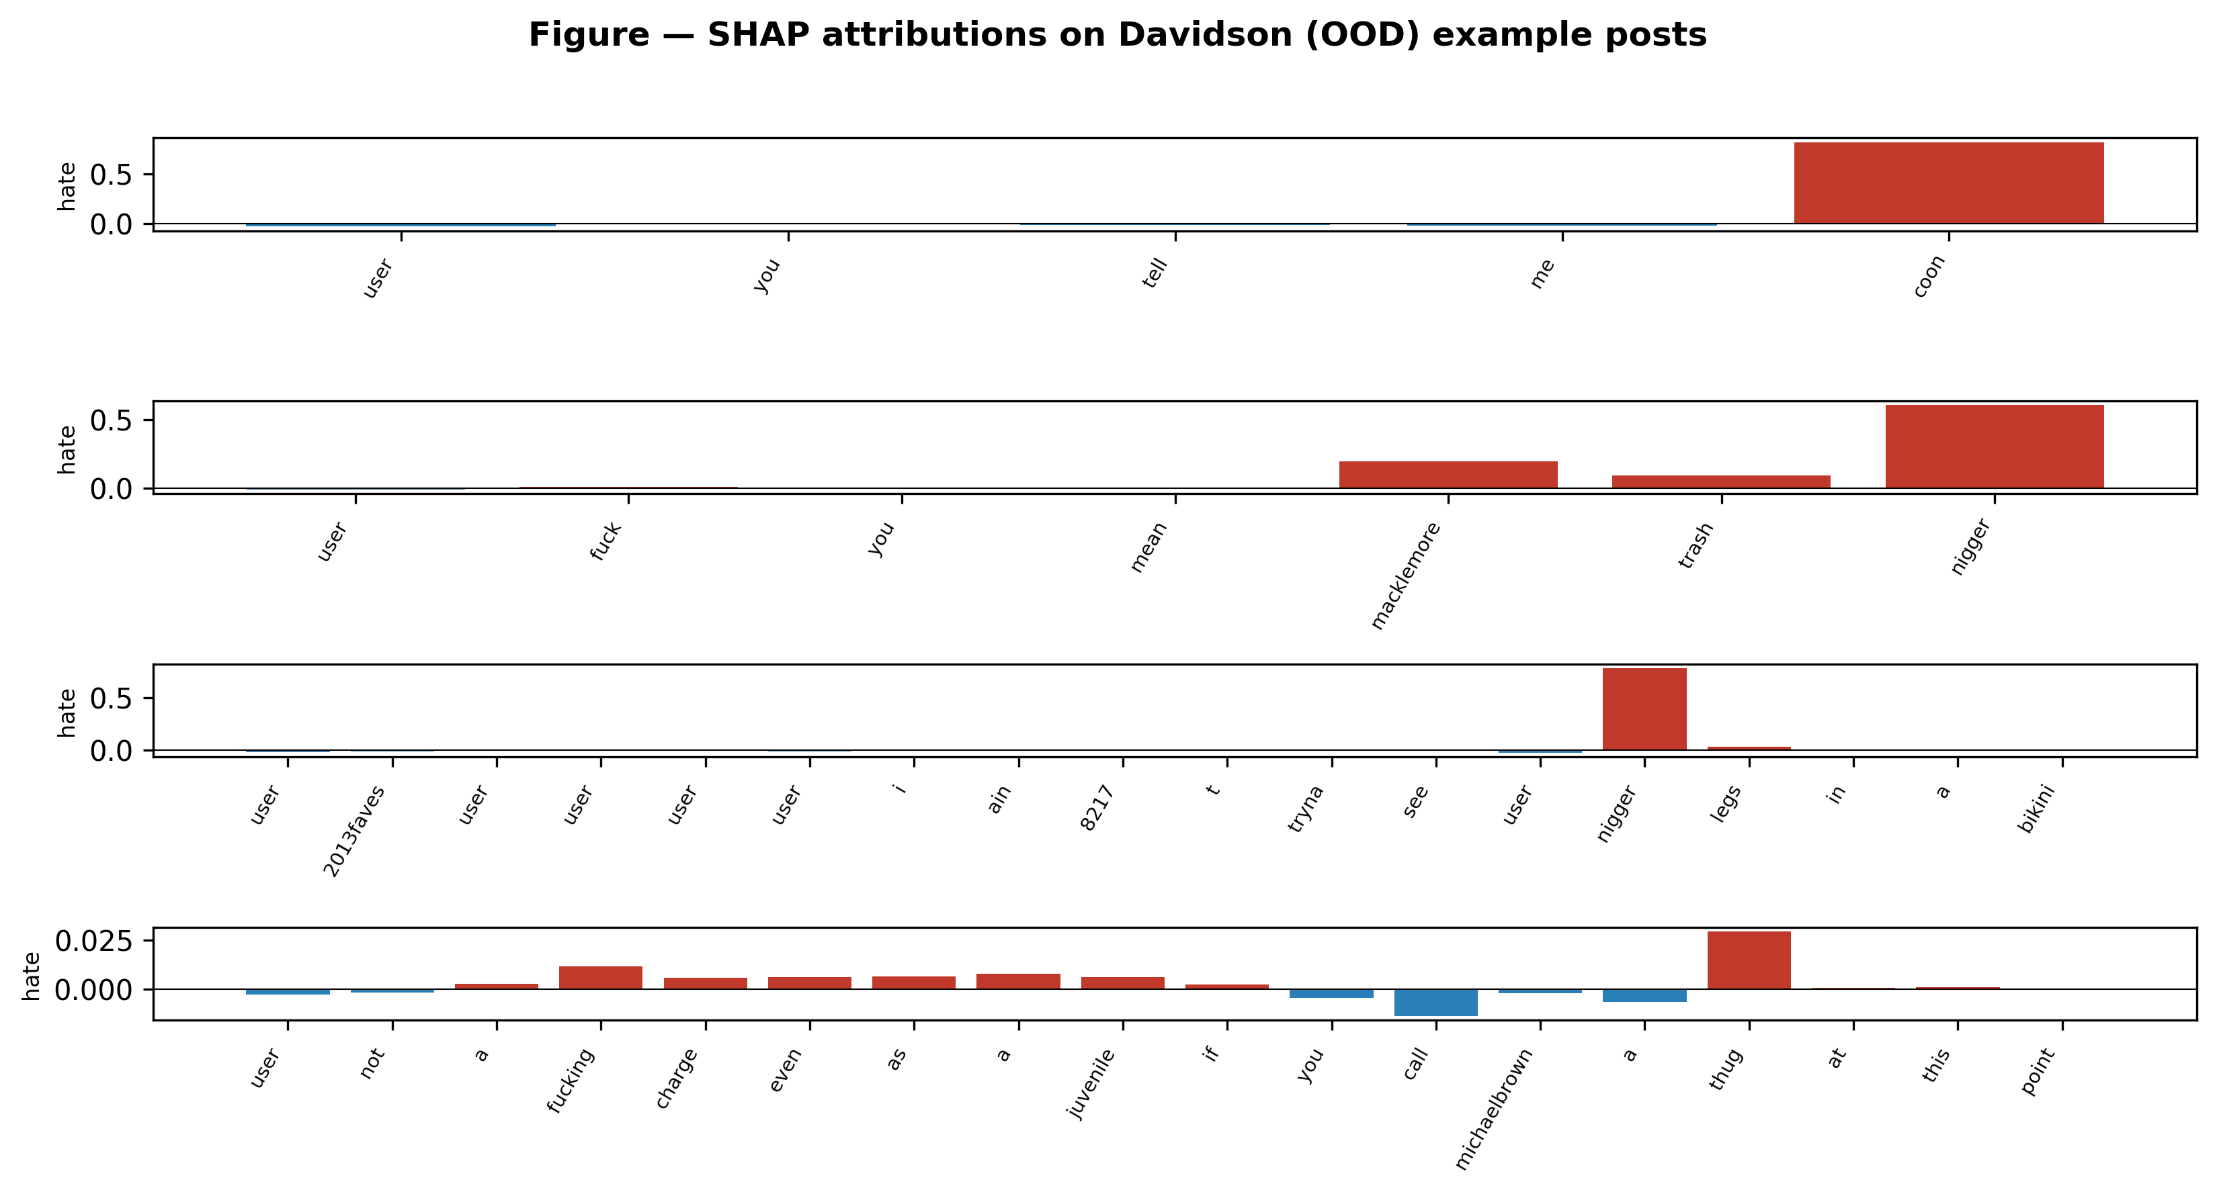
Graph (Exp 4) — SHAP attributions on Davidson (OOD) example posts; red bars = words pushing toward 'hate'. The model still latches onto slurs on a dataset it never trained on.
Kya result mila: Performance drops as expected zero-shot (in-domain macro-F1 ≈0.683 → OOD 0.483), but AUC stays high (0.802) — the model's RANKING ability transfers; only the calibrated thresholds don't. Crucially, the slur-centric explanation pattern transfers strongly (~71%), proving the explanations are a genuine property of hate speech, not a HateXplain artifact. The main error (offensive→normal) reflects Davidson's different annotation scheme.

Overall Summary — what changed for the paper
Experiment | Reviewer concern | What we found
1. Fusion ablation | Is a smarter fusion better? | No fusion wins both axes; mean_zscore is a free upgrade; reviewer's 'attention dominates' premise disproved.
2a. Larger-n (1,141) | Is n=300 enough? | CIs ~3x tighter, scores higher, all conclusions hold.
2b. Threshold sweep | Why cosine 0.70? | 0.70 maximises modularity over 0.50–0.85 → confirmed.
3. Multi-seed | Is BERT≈HateBERT a fluke? | Tie holds on all 3 seeds (p=0.86/0.96/0.23); std tiny.
4. OOD (Davidson) | Does it generalise? | Expected accuracy drop but AUC 0.80; explanations transfer ~71%.

Two honest notes for the manuscript:
- The reviewer's idea that attention dominates the min-max mean (via L1 mass) is empirically false — SHAP has the largest mass. The real reason no fusion dominates is the plausibility↔faithfulness trade-off. Frame the contribution as BALANCE, not superiority.
- mean_zscore is a small, principled, statistically-significant improvement over the current mean_minmax on faithfulness at no plausibility cost — worth adopting as the default fusion.

